**Global Economic and Demographic Trends Analysis: Business Requirement Document (BRD)**

**Project Information**

Global Economic and Demographic Trends Analysis

Moviraj D

May-2025

RP-36

Offline

B2024126094

:

:

:

:

:

:

**Title** : Laptop Dataset

**Name** : Moviraj D

**DA/DS** : May-2025

**Batch Number** : RP-36

**Online/Offline** : Offline

**Roll Number**

**Table of Contents**

* Introduction
* Dataset Overview
* Data Cleaning & Transformation
* Descriptive Statistical Analysis
* DAX Calculations & Measures
* Data Visualizations
* Dashboard Design
* Insights & Analysis
* Conclusion

**🔹 Introduction**

This project analyzes global economic and demographic data, focusing on population, GDP, literacy, and health indicators. Using **Excel, SQL, and Power BI**, the aim is to uncover patterns, trends, and relationships that highlight regional disparities and opportunities for sustainable growth.

**🔹 Dataset Overview**

* **CountriesWorld (SQL Database):** Country-level indicators such as population, GDP per capita, literacy, infant mortality, and demographics.
* **PopulationPerCountry (Excel):** Population data from 1960 to 2017.
* **GDP by Country (Excel):** GDP values from 1960 to 2016.
* **MetaData (Excel):** Region, income group, and classification details.

These datasets together provide a comprehensive view of global population and economic development.

**🔹 Data Cleaning & Transformation**

* Handled **missing values** and ensured data consistency.
* Standardized **country names and codes** across sources.
* Transformed wide-format time series data into **yearly records**.
* Built relationships between tables using **Country Code** as the key field.
* Removed duplicates and ensured proper **data types** for measures.

**🔹 Descriptive Statistical Analysis**

* **Population:** Mean, median, standard deviation calculated across countries.
* **GDP:** Average GDP per capita by country and region; highest & lowest GDP identified.
* **Infant Mortality:** Min, max, range, and standard deviation analyzed.
* **Literacy:** Average literacy rates across regions and countries.
* **Growth Trends:** Time-series analysis of population, GDP, and infant mortality from 1960–2017.

**🔹 DAX Calculations & Measures**

* **Population Growth Rate (%)**
* **GDP Growth Rate (%)**
* **GDP per Capita (calculated column/measure)**
* **Total Population by Region**
* **Correlation between Literacy & GDP**

These measures enabled deeper insights into trends and relationships.

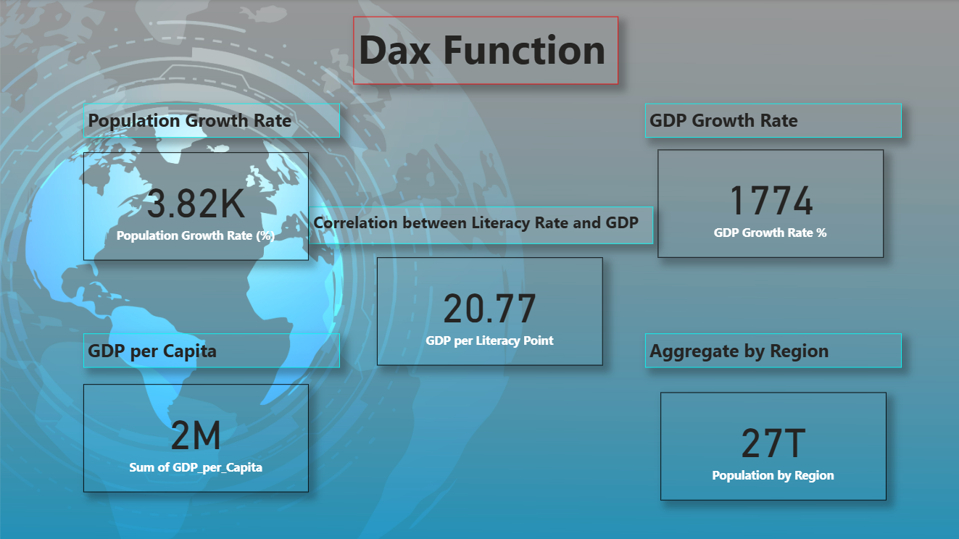

**🔹 Data Visualizations**

* **KPI Cards:** Population, GDP, Literacy, Infant Mortality.
* **Maps:** Population distribution, GDP per capita by region.
* **Line Charts:** Growth trends (Population, GDP, Infant Mortality).
* **Bar Charts:** Literacy rates & GDP per capita comparisons.
* **Scatter Plot:** Literacy vs GDP correlation.

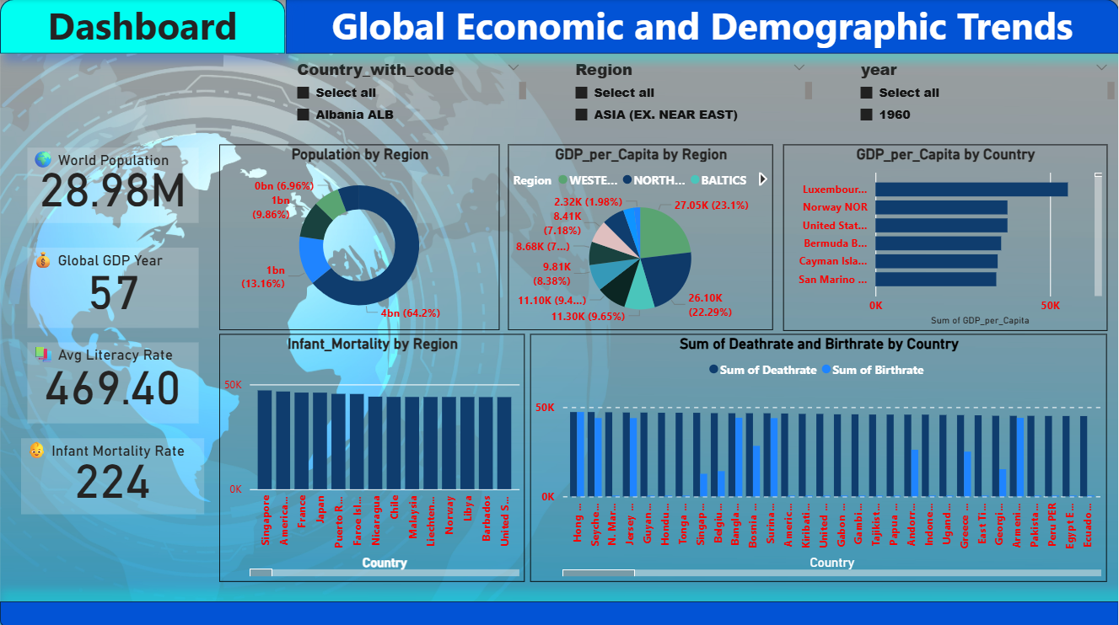

**🔹 Dashboard Design**

* **Top KPIs** at a glance for global summary.
* **Interactive filters (slicers)** for Year, Region, and Income Group.
* **Clean, consistent layout** with balanced visuals and storytelling flow.
* **Color-coded insights** for better readability (green = positive, red = concern).

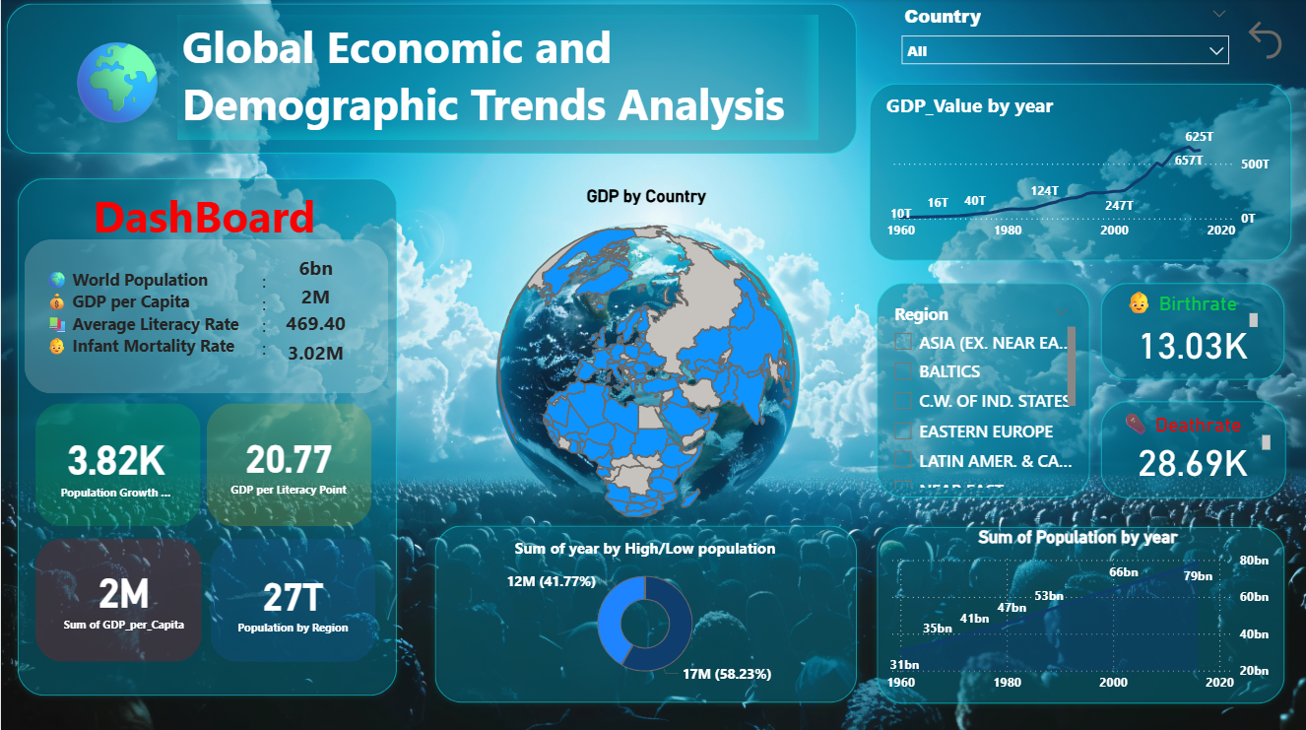

**🔹 Insights & Analysis**

* Developing regions show **high population growth** but **low GDP per capita**.
* **Higher literacy** strongly correlates with **higher GDP levels**.
* Infant mortality has **declined globally** but remains high in low-income regions.
* Asia and Africa drive much of the **global population increase**.

**🔹 Conclusion**

The analysis shows that while global population has more than doubled since 1960, **economic and social progress remains uneven**. Education and healthcare are critical drivers of prosperity. Sustainable, inclusive development policies are essential to reduce disparities and ensure long-term growth.

Github link : [GDP-Project](https://github.com/Movi1234/GDP-Project)